Complete and submit this form, along with a U.S. Soccer Referee Report, to the appropriate competition authorities (e.g., local league, tournament director, cup coordinator, etc.) as directed for the dismissal of team officials, sending-off offenses, serious injuries, game abandonment or other substantial occurrences. For instances of referee assault or referee abuse, complete and submit this form, along with a U.S. Soccer Referee Report, to the appropriate competition authorities (e.g., local league, tournament director, cup coordinator, etc.), State President with jurisdiction for the competition and State Referee Administrator.

Home Team: Score: This IS a Violent Conduct Incident
Away Team: Score: This IS NOT a Violent Conduct Incident
Association/League: Division/Age Group:
Game Number: Game Date:
Player received the Red Card is: Player’s number: From Team:
Player injured? Yes No Name of Player Injured:
Time of Incident:
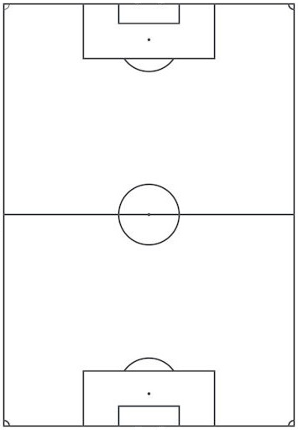

Referee’s Name: Phone Number:
USSF ID Number:
Email Address: A copy of the report must be sent to the SRA and the League

